Practical-7

Create a Single Node

1. **To create a single node in Neo4j, specify the name of the node along with CREATE statement.**

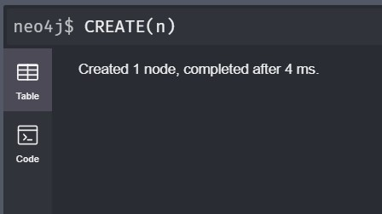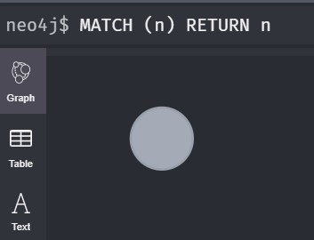

1. Create Multiple Nodes To create multiple nodes in Neo4j, use CREATE statement with the name of nodes separated by a comma.

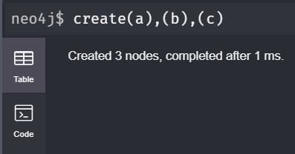

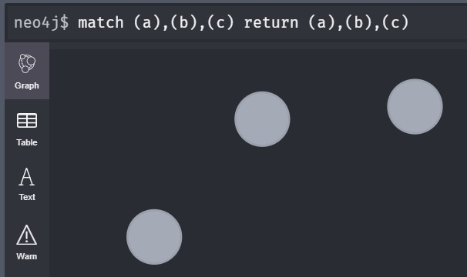

Create a node with a label

1. In Neo4j, a label is used to classify the nodes using labels. CREATE statement is used to create a label for a node in Neo4j.

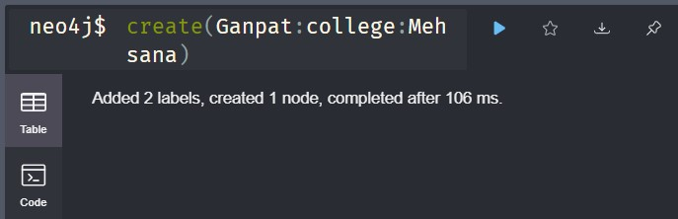

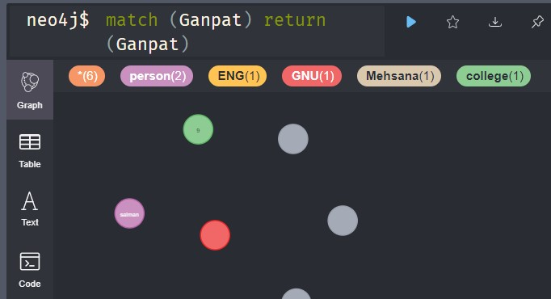

Create a Node with Multiple Labels

1. To create multiple labels with a single node, you have to specify the labels for the node by separating them with a colon " : ".

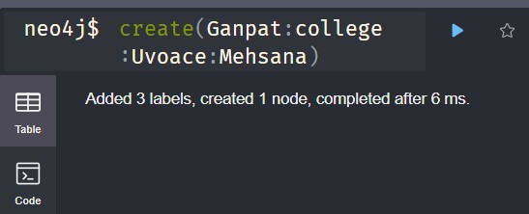

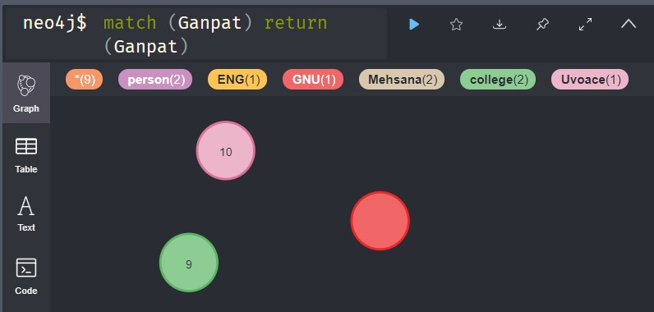

Create Node with Properties

1. In Neo4j, properties are the key-value pairs which are used by nodes to store data. CREATE statement is used to create node with properties, you just have to specify these properties separated by commas within the curly braces "{ }".

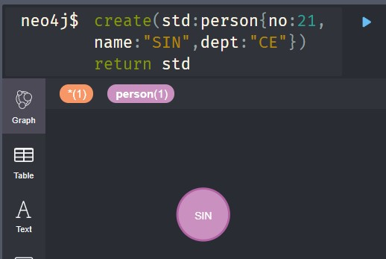

Creating Relationship

1. While creating a relationship, a relationship should be specified within square braces "[ ]", depending on the direction of the relationship it is placed between hyphen " - " and arrow " > " as shown in the following syntax.

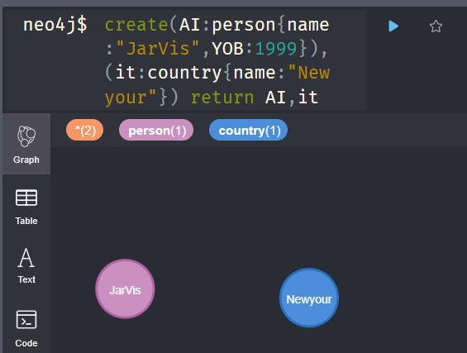

Now create a relationship “Person_of” between these two nodes as...

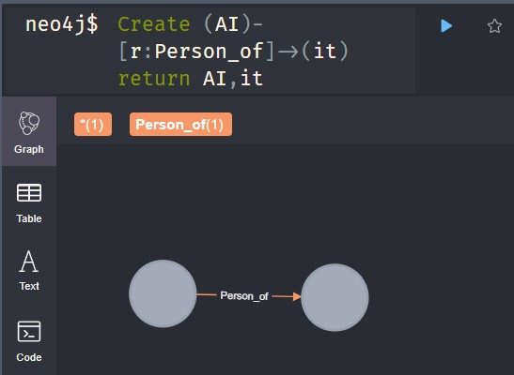

Create a Relationship between existing Nodes

1. MATCH statement is used to create relationships between the existing Nodes.

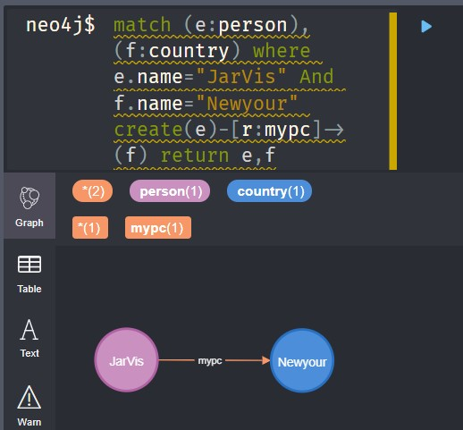

Neo4j Delete a Node

1. In Neo4j, DELETE statement is always used with MATCH statement to delete whatever data is matched. The DELETE command is used in the same place we used the RETURN clause in our previous examples.

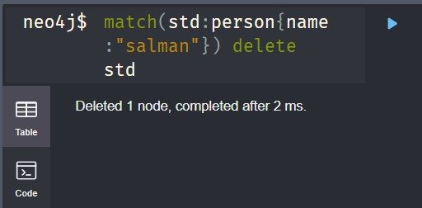

Neo4j Delete a Relationship

1. Deleting relationships is as simple as deleting nodes. Use the MATCH statement to match the relationships you want to delete. You can delete one or many relationships or all relationships by using one statement.

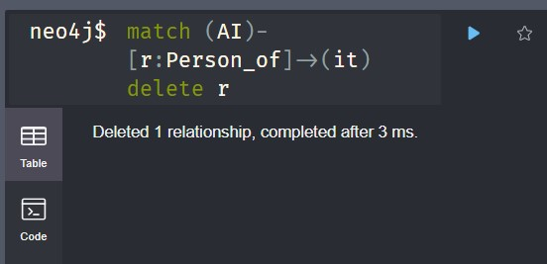

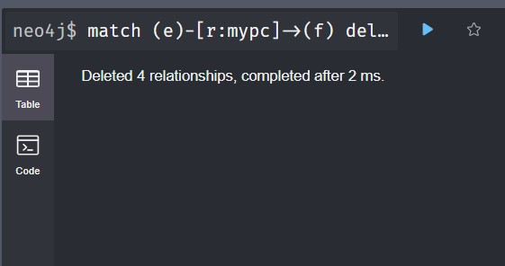

Delete All Nodes

1. To delete all nodes from the database, don?t use any filter criteria.

MATCH (n) DELETE n

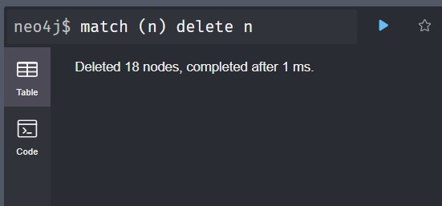

Example:

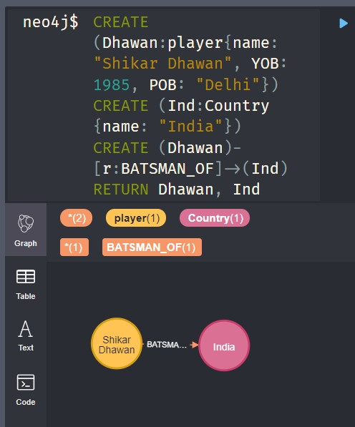

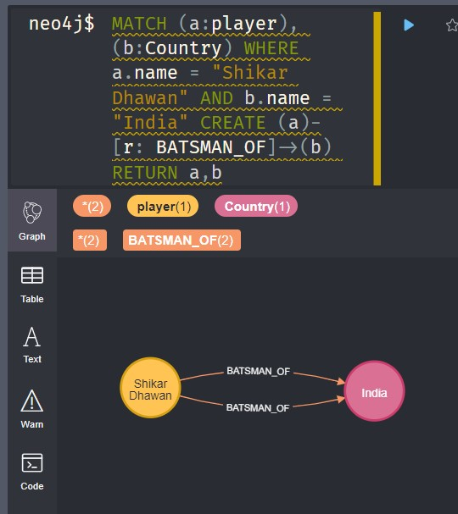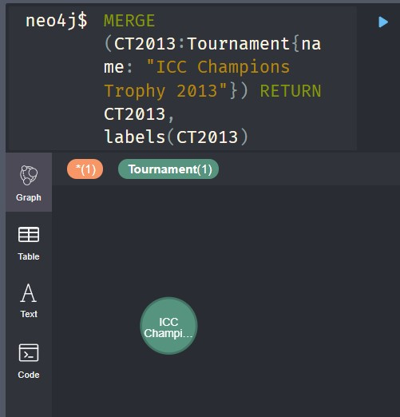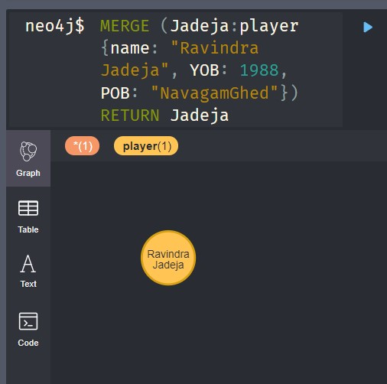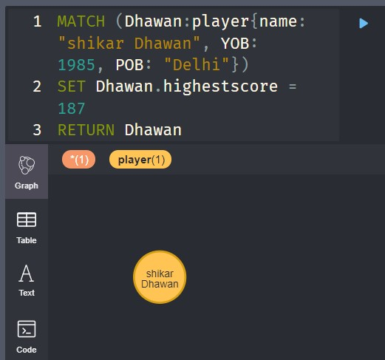

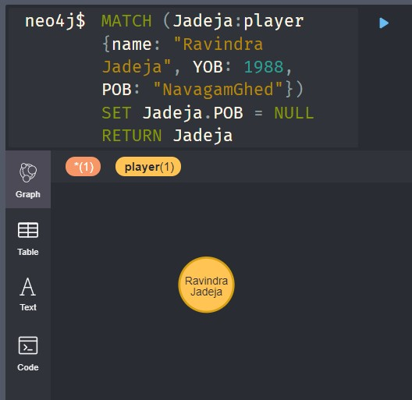

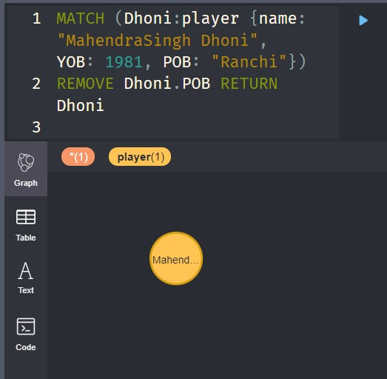

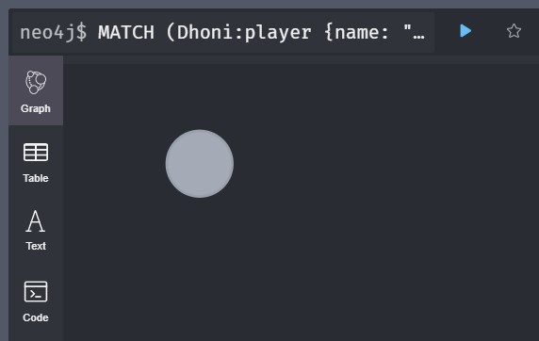

THE COMPLETE DATASET:

